CREATE TABLE

|  |
| --- |
| CREATE TABLE books (  book_id INT AUTO_INCREMENT PRIMARY KEY, -- Primary key with auto-increment  title VARCHAR(255) NOT NULL, -- Book title, cannot be NULL  author VARCHAR(255) NOT NULL, -- Author name, cannot be NULL  borrowed_date DATE -- Borrowed date in YYYY-MM-DD format  ); |

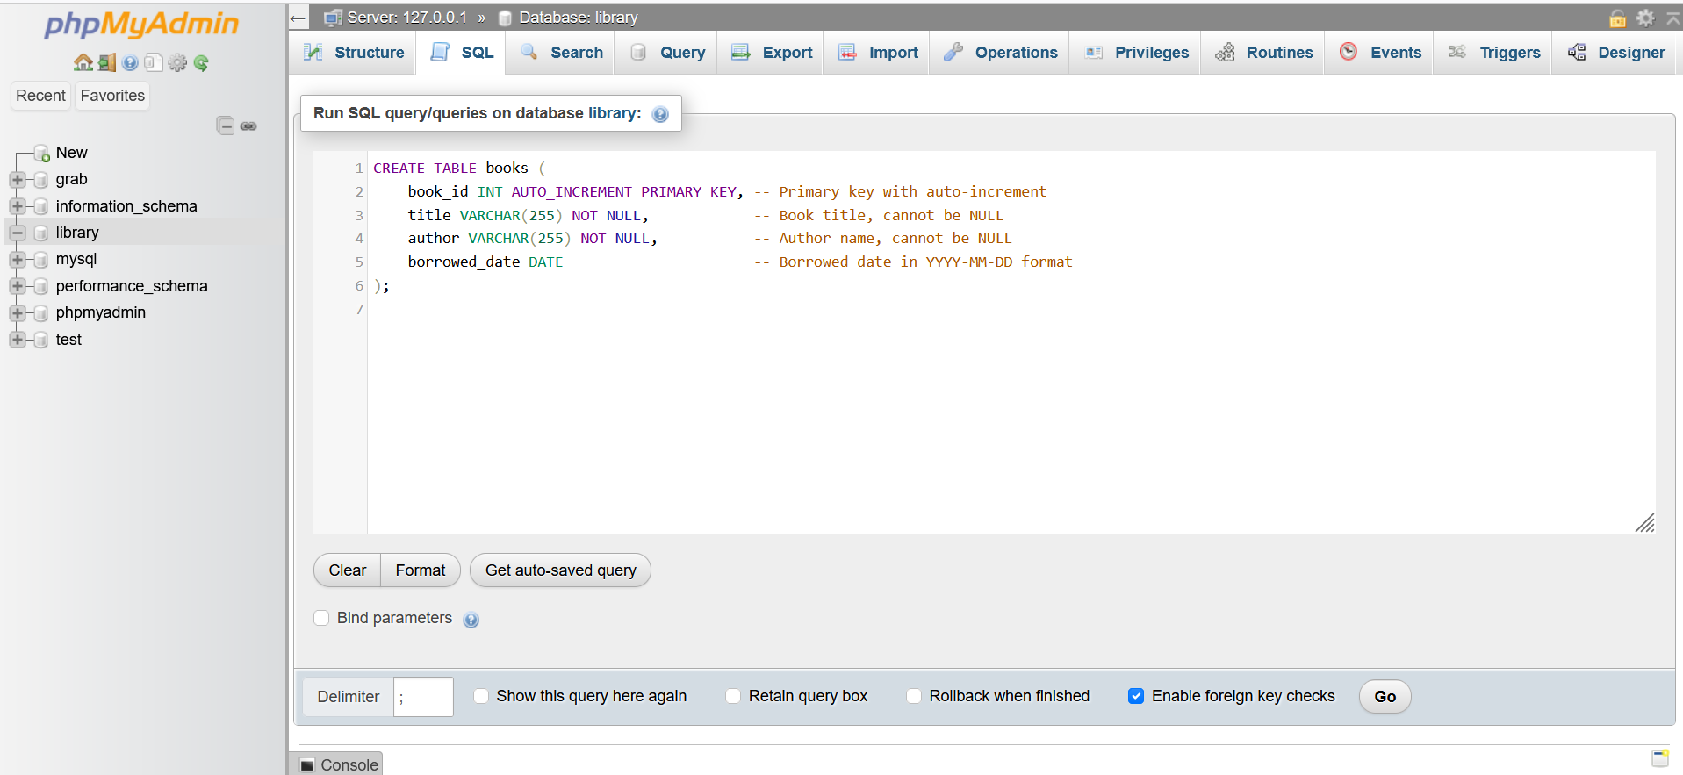

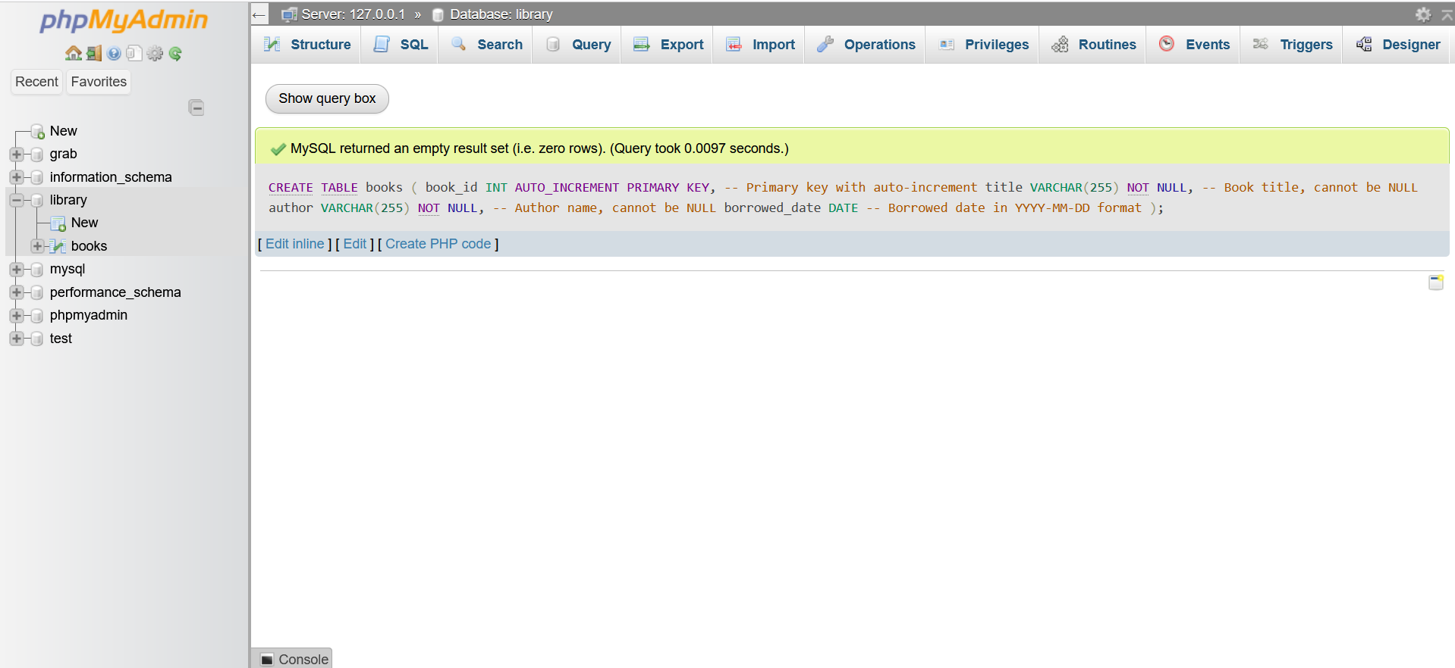

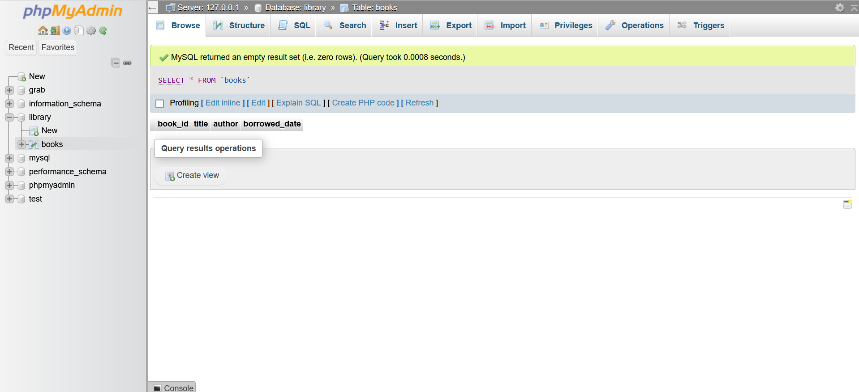

DATA ENTRY

|  |
| --- |
| INSERT INTO books (title, author, borrowed_date)  VALUES  ('To Kill a Mockingbird', 'Harper Lee', '2024-12-01'),  ('1984', 'George Orwell', '2024-12-05'),  ('The Great Gatsby', 'F. Scott Fitzgerald', '2024-11-28'),  ('Pride and Prejudice', 'Jane Austen', '2024-11-20'),  ('Moby-Dick', 'Herman Melville', '2024-12-10'); |

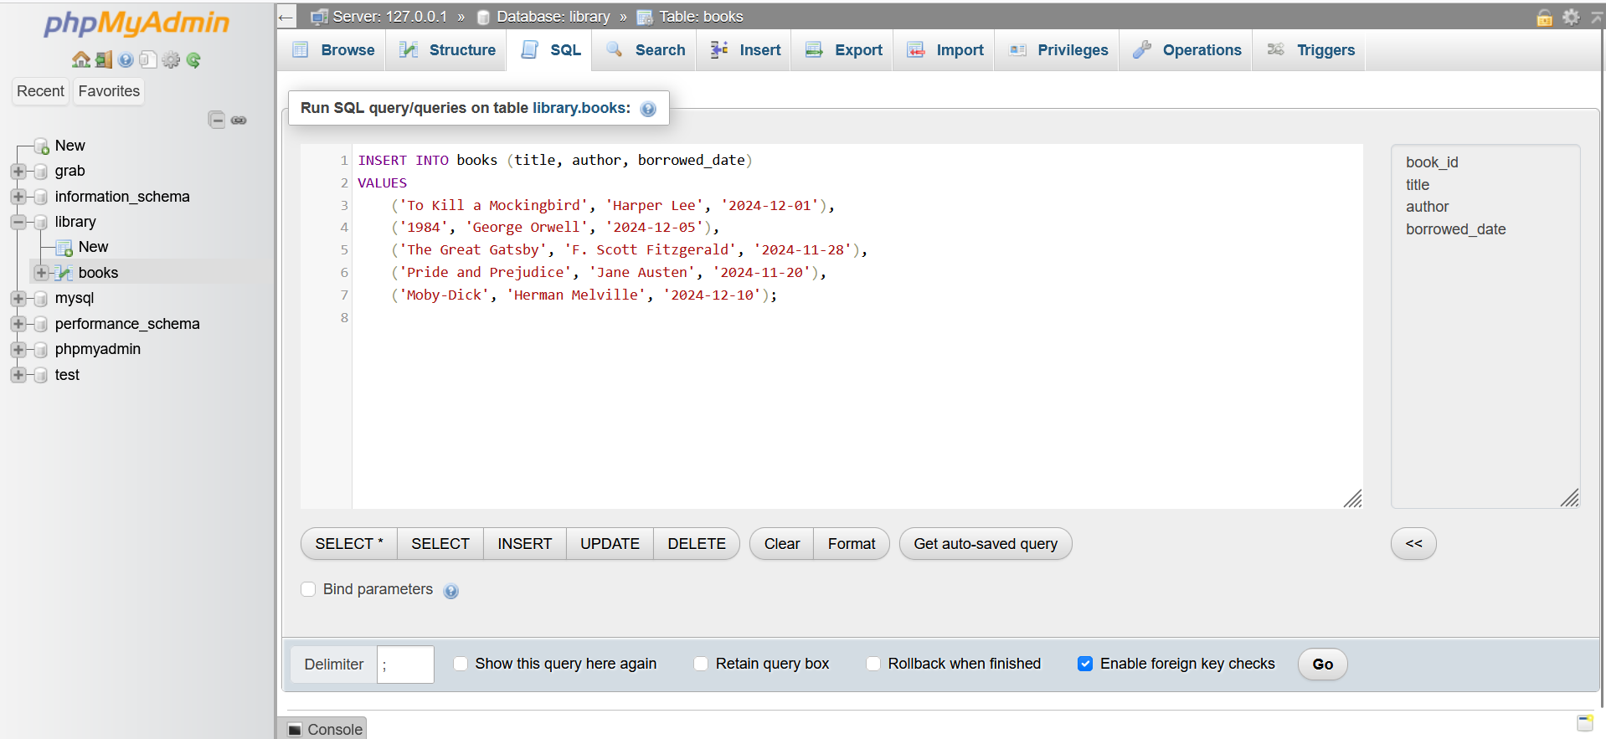

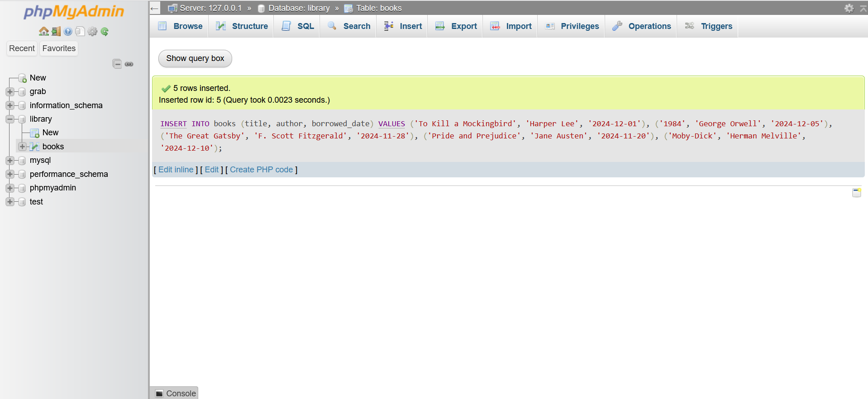

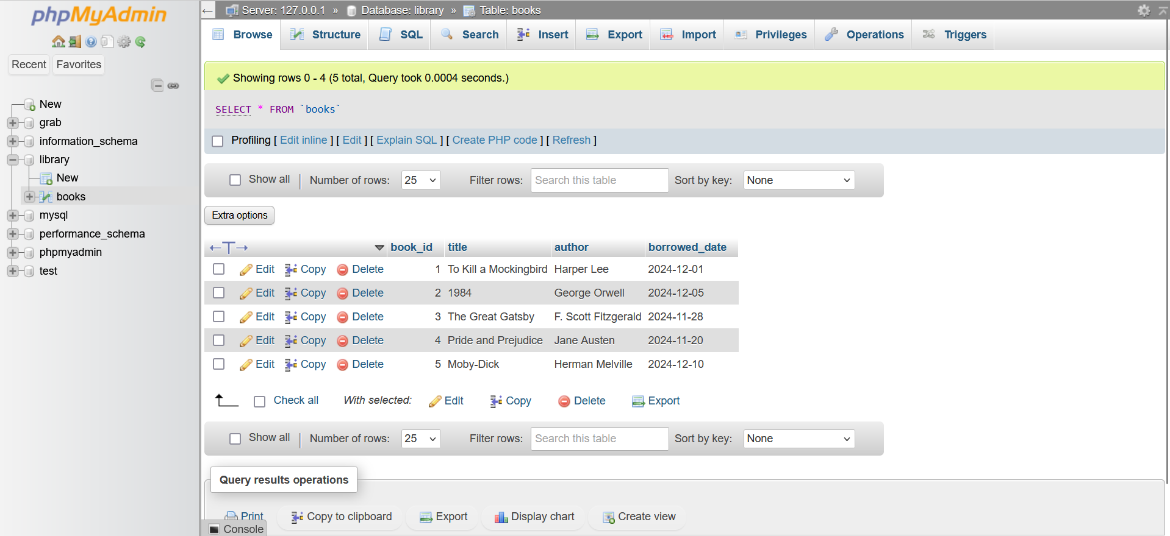

Basic query

1. List all books

|  |
| --- |
| SELECT * FROM books; |

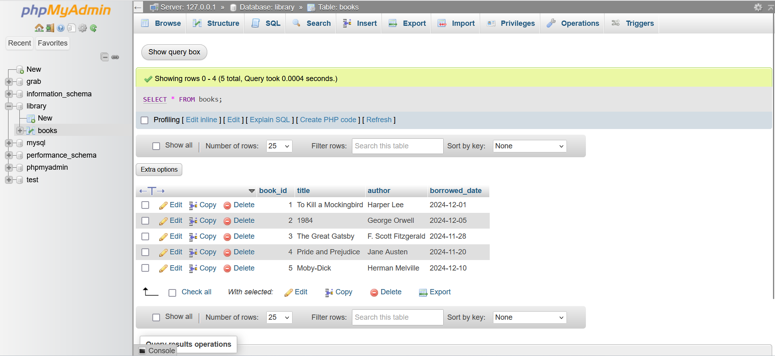

1. Find books by author

|  |
| --- |
| SELECT * FROM books  WHERE author = 'Jane Austen'; |

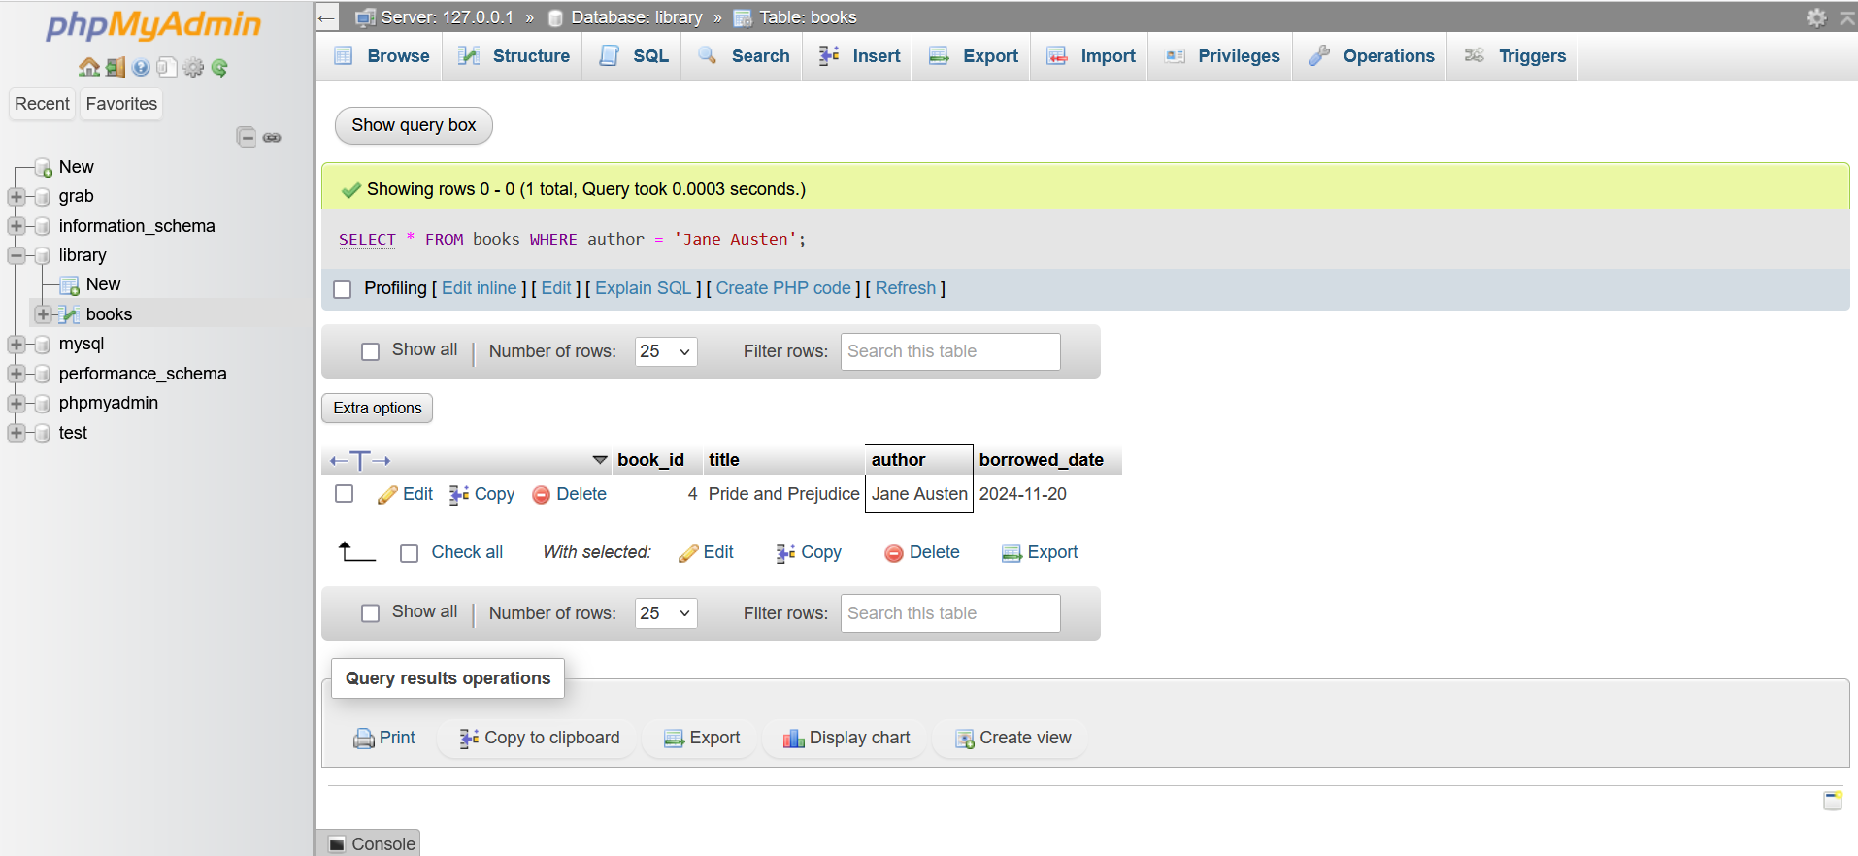

1. Finds books borrowed after a specific date

|  |
| --- |
| SELECT * FROM books  WHERE borrowed_date = '2024-12-01'; |

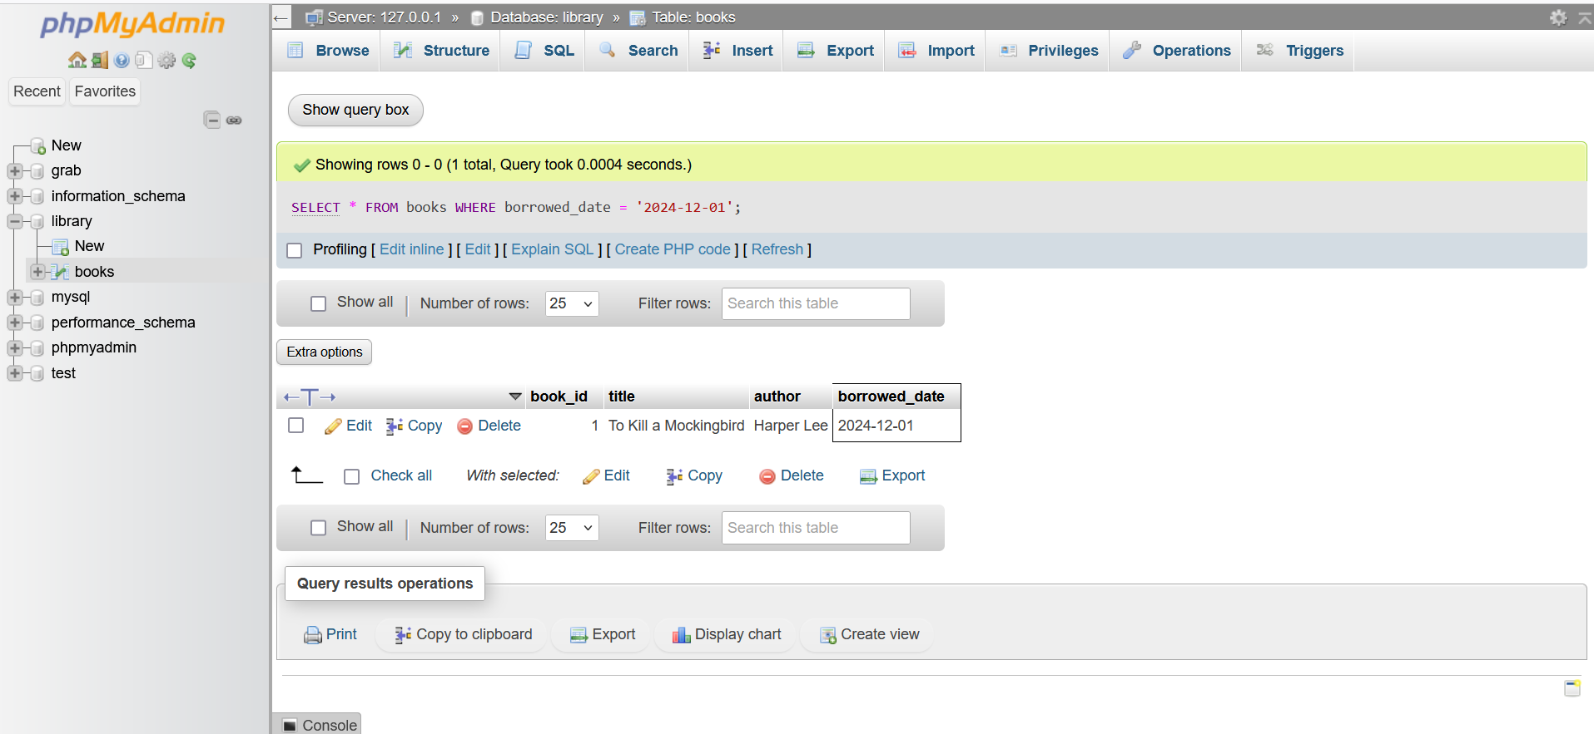

1. Find books borrowed after a certain date

|  |
| --- |
| SELECT * FROM books  WHERE borrowed_date > '2024-12-01'; |

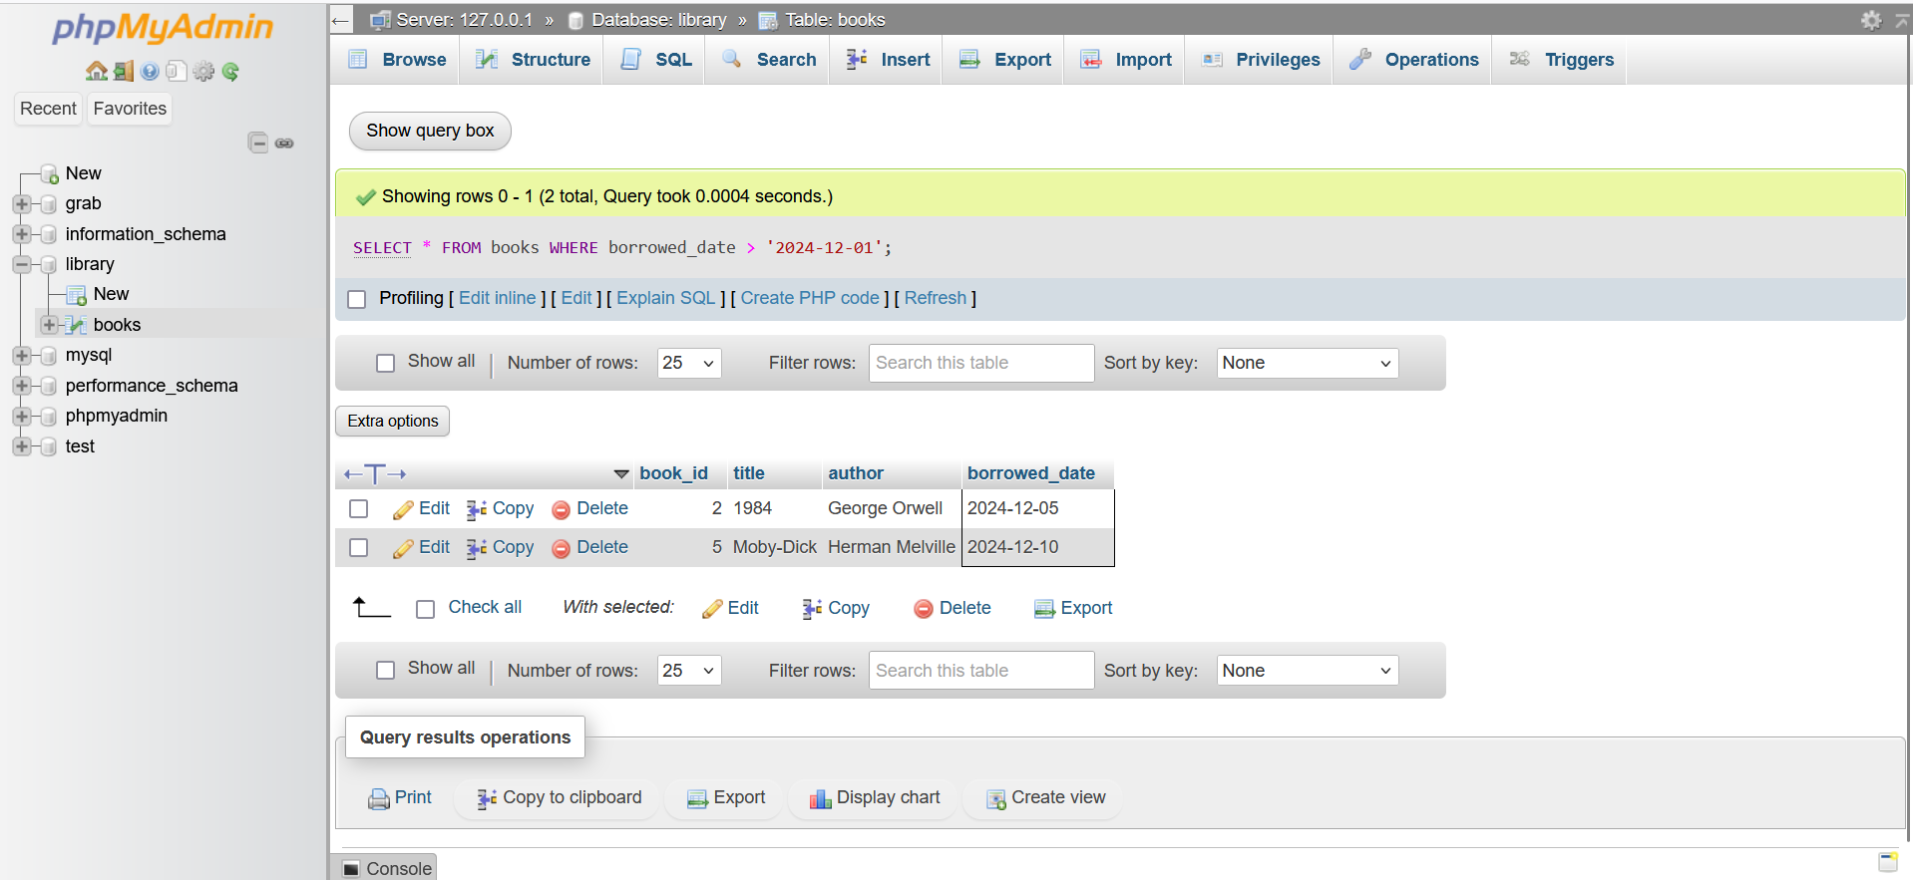

Data Manipulation

1. Update

|  |
| --- |
| UPDATE books  SET borrowed_date = '2024-12-15'  WHERE book_id = 3; |

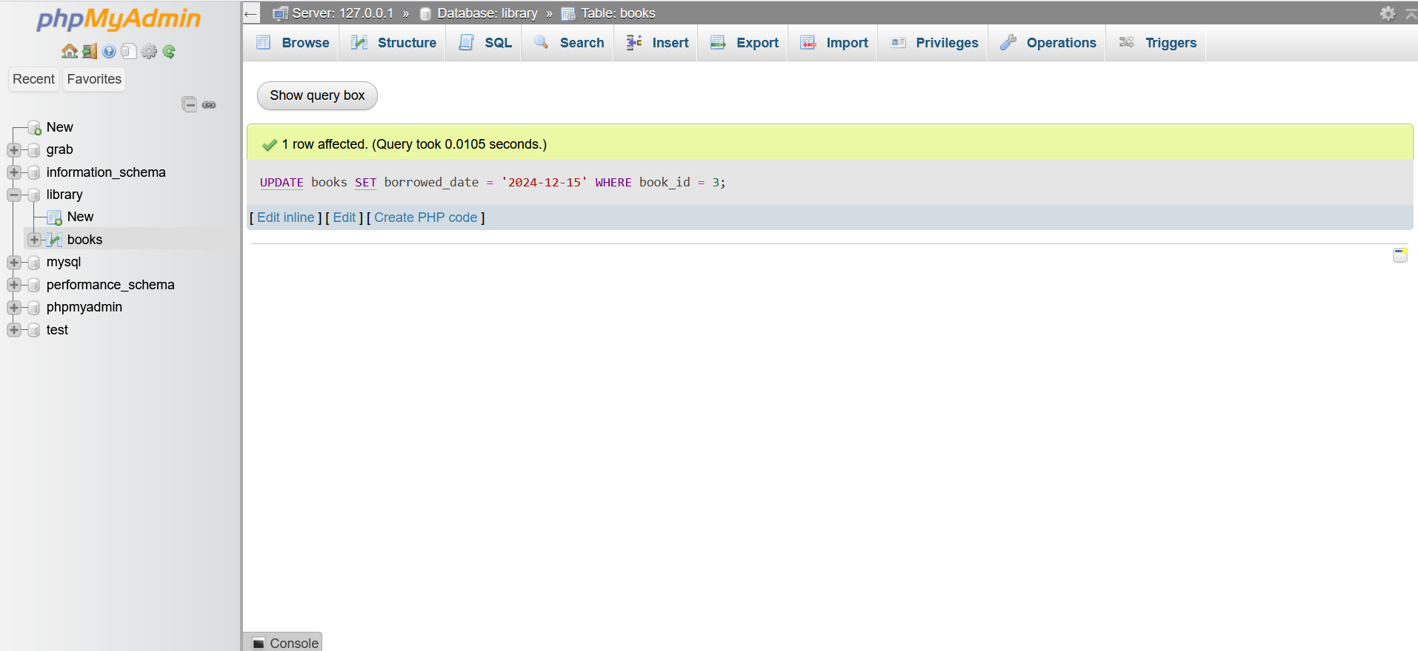

1. Delete a book

|  |
| --- |
| DELETE FROM books  WHERE book_id = 4; |

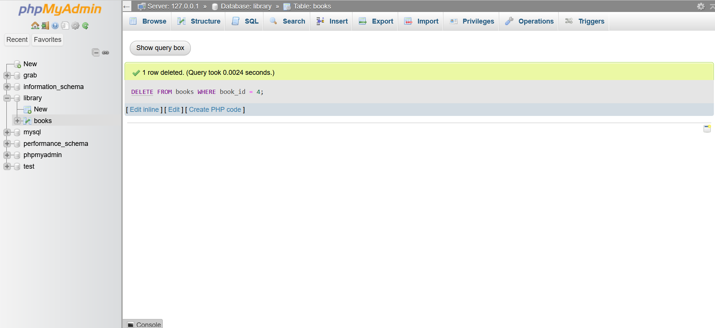

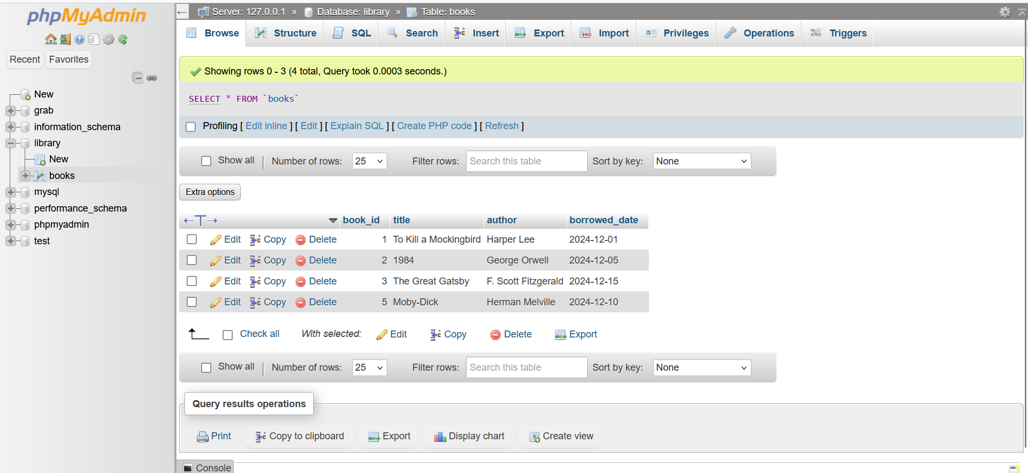

1. Re-add a deleted book

|  |
| --- |
| INSERT INTO books (title, author, borrowed_date)  VALUES ('Pride and Prejudice', 'Jane Austen', '2024-11-20'); |

